HR DATA DASHBOARD REPORT
ABSTRACT:
This project presents an interactive HR Analytics Dashboard created using Microsoft Excel. The dashboard is designed to analyze employee-related data such as income, job roles, performance ratings, and attrition. It helps organizations understand workforce distribution and key performance indicators. The dashboard uses slicers and charts for dynamic filtering and visualization. The black and gold theme enhances readability and presentation quality. This report explains the structure, features, and insights derived from the dashboard.
OUTPUT:
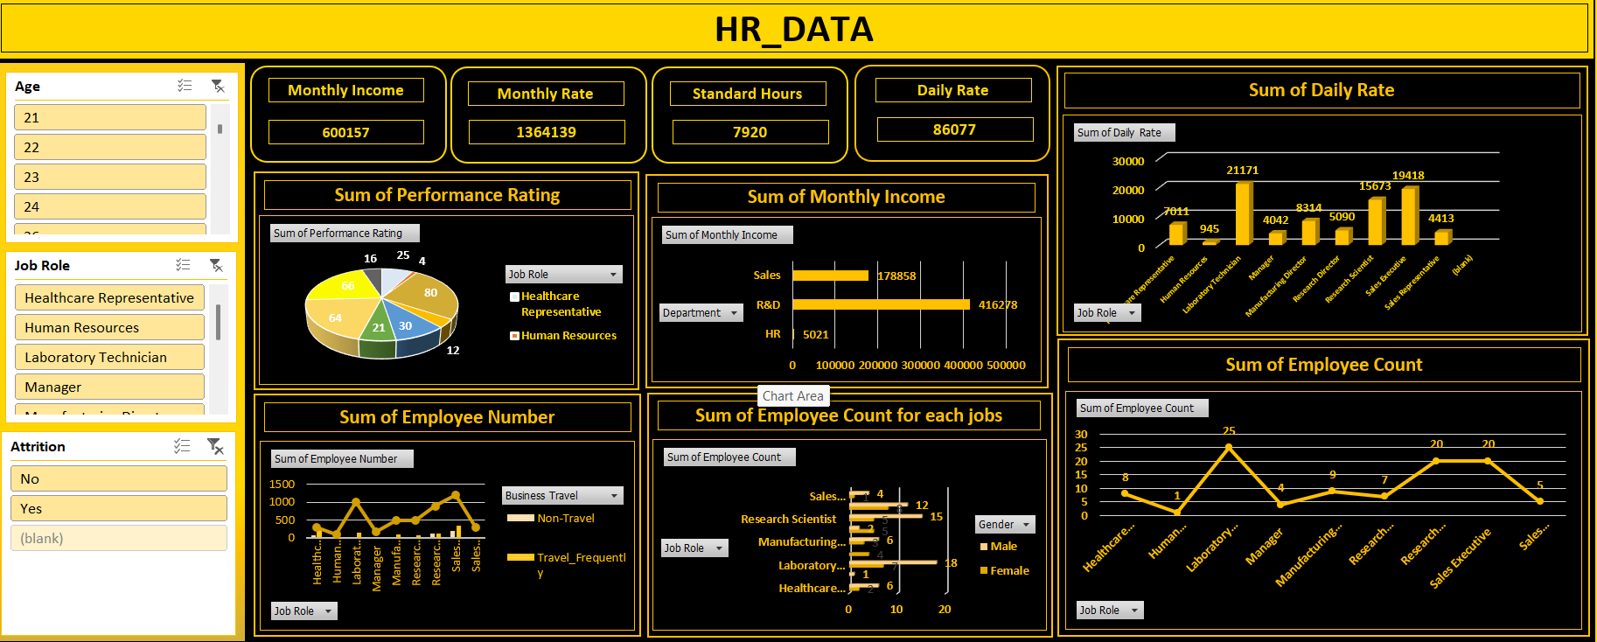

OBJECTIVE:
The main objectives of this dashboard are:
- To analyze employee salary distribution
- To understand performance ratings
- To monitor employee count by job roles
- To study attrition trends
- To provide quick and interactive insights

DATASET DESCRIPTION:
The dataset used in this dashboard includes:
- Age
- Job Role
- Department
- Monthly Income
- Daily Rate
- Performance Rating
- Attrition (Yes/No)
- Gender
- Business Travel
This data helps in understanding employee behavior and company workforce structure.

TOOLS USED:
- Microsoft Excel
- Pivot Tables
- Pivot Charts
- Slicers
- Data Cleaning Techniques

DASHBOARD FEATURES:
🔹 KPI CARDS:
The dashboard includes key performance indicators:
- Monthly Income: 600,157
- Monthly Rate: 1,364,139
- Standard Hours: 7,920
- Daily Rate: 86,077
These KPIs give a quick overview of employee compensation.

🔹 FILTERS (SLICERS):
The dashboard includes interactive filters:
- Age
- Job Role
- Attrition
Users can dynamically filter the data for better analysis.

🔹 CHARTS USED:
1. Performance Rating (Pie Chart)
Shows distribution of employee performance ratings.
2. Monthly Income (Bar Chart)
Displays income distribution across departments like Sales, R&D, and HR.
3. Daily Rate (Column Chart)
Shows daily salary variation across different job roles.
4. Employee Count (Line Chart)
Represents number of employees in each job role.
5. Employee Number (Trend Chart)
Shows employee distribution based on travel type.
6. Job-wise Employee Count (Bar Chart)
Displays count of employees categorized by job roles and gender.

INSIGHTS:
- R&D department has the highest income contribution
- Laboratory Technicians have the highest employee count
- Sales Executives also show strong presence
- Performance ratings are fairly distributed
- Attrition can be analyzed using filters
- Travel frequency impacts employee distribution

ADVANTAGES:
- Easy to understand
- Interactive filtering
- Clear data visualization
- Helps in decision-making
- Professional design

CONCLUSION:
The HR Dashboard provides a comprehensive overview of employee data. It helps organizations make data-driven decisions by analyzing workforce trends, salary distribution, and performance metrics. The use of Excel tools makes it efficient and easy to maintain.

FUTURE ENHANCEMENTS:
- Add predictive analytics
- Include employee satisfaction metrics
- Connect with real-time data
- Use Power BI for advanced visualization

